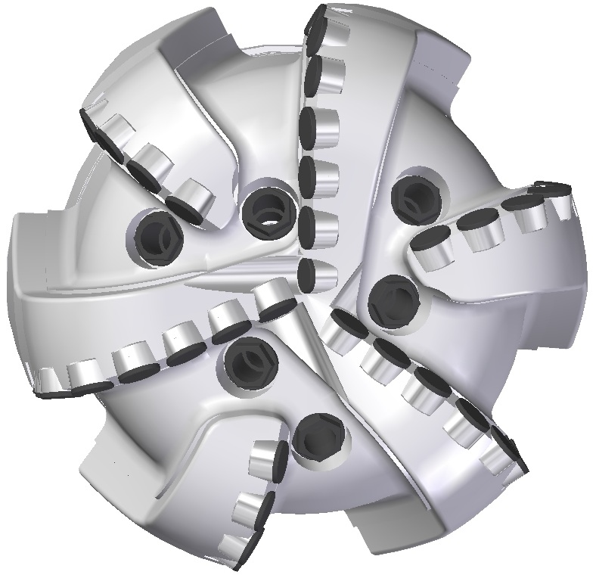 |  | 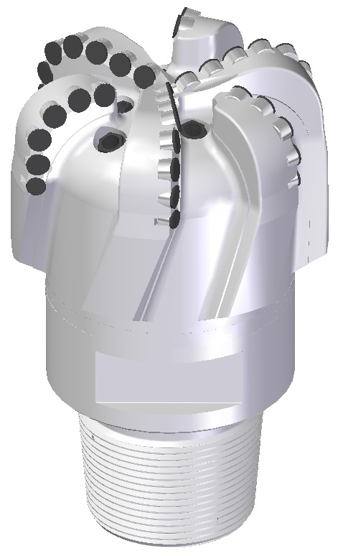

Drill Bit Specifications:
Cutter Size (Primary, Sec) | 3/4” , 5/8”
Cutter Count (Total, Gage) | 32 , 7
Blade Count | 6
Gage Length (Inches) | 3.00
Nozzle Count (Primary, Sec.) | 6
Nozzle Size (Primary, Sec.) | 60
JSA (Sq. Inches) | 17.60
Max. TFA (Sq. Inches) | 1.49
Operating Parameters:
Max. Hydraulic Flow Rate (GPM) | 465
Max. Weight on Bit (1,000 Lbs.) | 37
Make-up Torque (ft/lbs) | 40,563
Nominal Dimensions:
Overall Length (Inches) | 16.000
Make Up Length (Inches) | 11.125
Bit Breaker | SKB-21011
Connection | Ø6-5/8" API Reg.
Approx. Weight (Lbs.) | 165

Standard Features:

- Large open face volume assists cuttings removal
- Six nozzles optimize blade cleaning and cuttings removal
- Premium grade cutters maximize ROP and Life

619-SR Nomenclature Explained:

- 6 = Number of Blades
- 19 = Primary Cutter Size (19mm)
- SR = Single Row of Cutters

